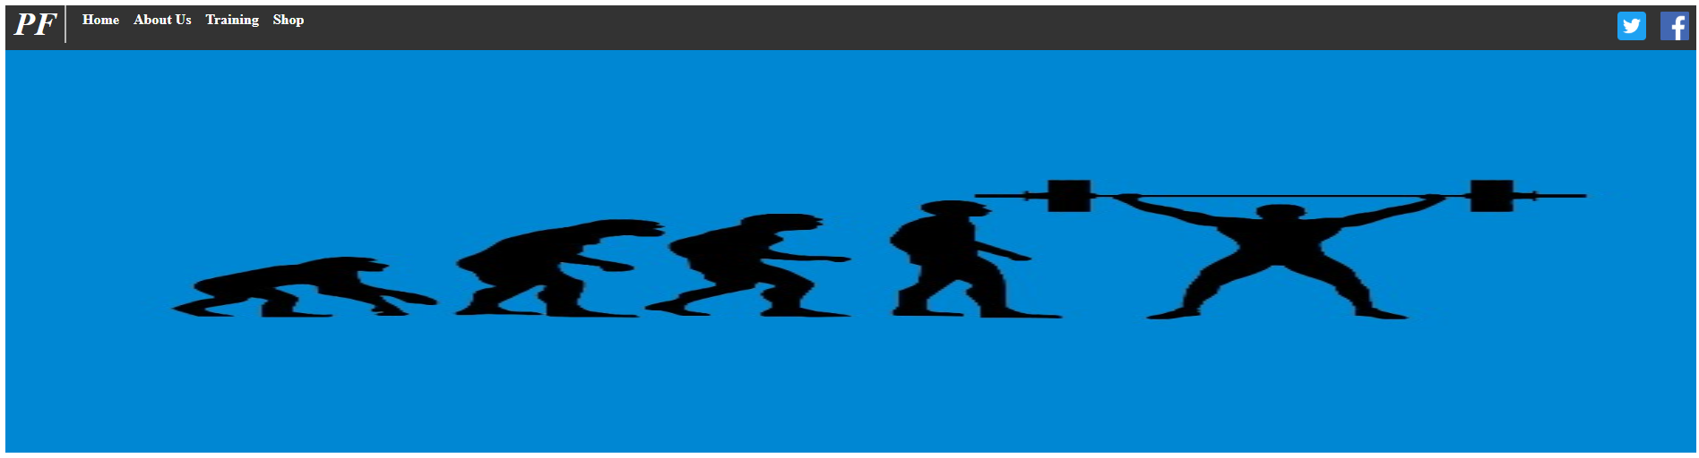



Each elements width and height is a % to improve responsiveness and the nav buttons change colors when hovered over

